Department of
Computer Science and Engineering
CSE324 Operating System Lab
Lab Report - 04

- Shells Script (Variable & Conditional)
Topic Name:

Submitted to
Fardowsi Rahman
Lecturer
Department of CSE
Daffodil International University
Submitted by
Name: Foysal Mahamud Fahim
ID: 232-15-334
Section: 65_M2
Semester: 7th Semester (Spring 2026)

Remark:
Submission Date: 02/02/2026

Table of Contents
- Topic 1-1
  - Topic Overview 1
- Basic Commands 1-9
2.1 Create shell file (input.sh) 1
2.2 Variable Assignment 1
2.3 Comparison Operators (-gt) 2
2.4 Create file using variable 3
2.5 Using direct Symbol 4
2.6 If elif else condition 5
2.7 Word check 6
2.8 Word user input check 6
2.9 Division two number from user input 7
2.10 Task 1 (Voter check) 8

Bash Script Conditional & Variable
Topic Overview
- Basic If Condition
- User Input with If Condition
- Create File Using Variable
- Direct Symbol Arithmetic Check
- If-Elif-Else Condition (Number Check)
- Word Check (Fixed Value)
- Word Check (User Input)
- Division with Zero Check
- Voter Eligibility Check

Create and Edit Script
Command: touch input.sh
Description: Creates an empty file named input.sh to hold the shell script.
Command: nano input.sh
Description: Opens the file in the nano editor. This is where the script logic (variables and loops) is written.

1.Variable Assignment
Commands:
count=15
if [ $count -gt 12 ]
then
echo "Condition is true"
else
echo "Condition is false"
fi

Description:
This Bash script assigns the value 15 to the variable count. It then uses an if condition to compare whether count is greater than 12. Because the condition is true, the script executes the then block and prints "Condition is true". If the condition were not satisfied, the else block would execute and print "Condition is false".



View: ./input.sh

2.Comparison Operators (-gt)

Commands:
echo "Enter a number"
read count
if [ $count -gt 12 ]
then
echo "Condition is true"
else
echo "Condition is false"
fi

Description:
This Bash script first asks the user to enter a number and stores the input in the variable count. It then checks whether the entered value is greater than 12 using an if-else condition. If the condition is true, it prints "Condition is true"; otherwise, it prints "Condition is false".

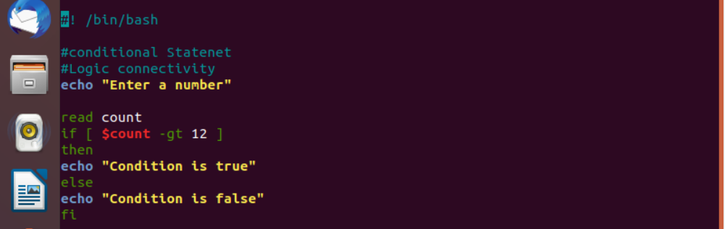

View: ./input.sh

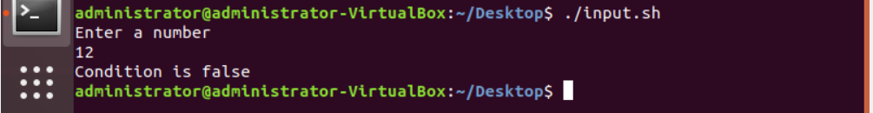

3.Create file using variable
Commands:
echo "Enter your file name"
read name
echo "I will create a file called ${name}"
touch "${name}.sh
Description:
This Bash script asks the user to enter a file name and stores it in the variable name. The read command takes the file name as input from the user. It then displays a message showing the name of the file that will be created. The touch command is used to create a new file with the .sh extension. As a result, a shell script file with the given name is created.

View: ./input.sh


File: fahim.sh (create another file name fahim.sh)
View: ./fahim.sh

4.Using direct Symbol
Commands:
echo "Enter a number"
read sum
if(($sum>20))
then
echo "Condition is true"
else
echo "Condition is false"
fi

Description:
This Bash script prompts the user to enter a number and stores it in the variable sum. The read command is used to take numeric input from the user. An arithmetic if condition checks whether the value of sum is greater than 20. If the condition evaluates to true, the script prints "Condition is true". Otherwise, it prints "Condition is false".

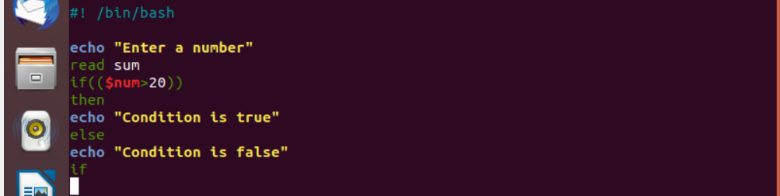
View: ./fahim.sh
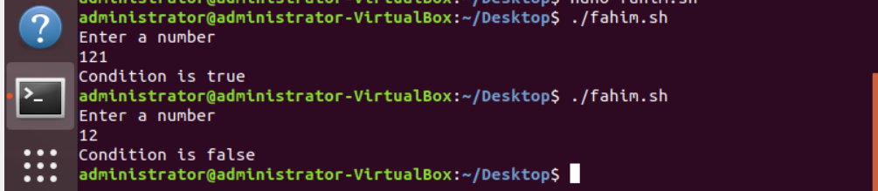

5.If elif condition
Commands:
echo "Enter a number"
read num
if [ $num -eq 0 ]
then
echo "Number is zero"
elif [ $num -et 0 ]
then
echo "Number is Positive"
else
echo "Number is negative"
fi

Description:
This Bash script asks the user to enter a number and stores it in the variable num. First, it checks if the number is equal to zero using the -eq operator. If the number is zero, it prints "Number is zero". Then it checks whether the number is positive using the greater-than condition (-gt). If neither condition is true, the script prints "Number is negative".
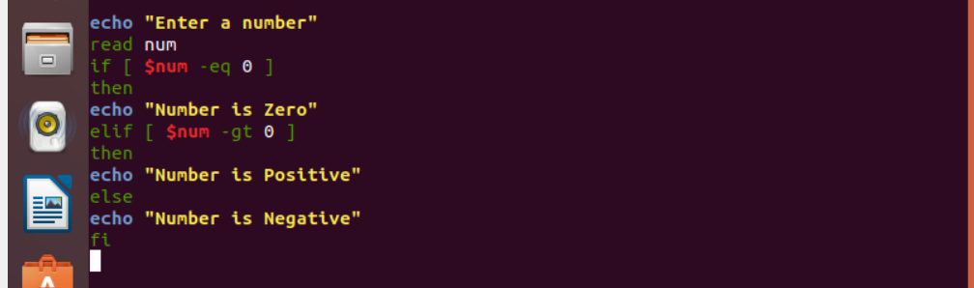

View: ./fahim.sh
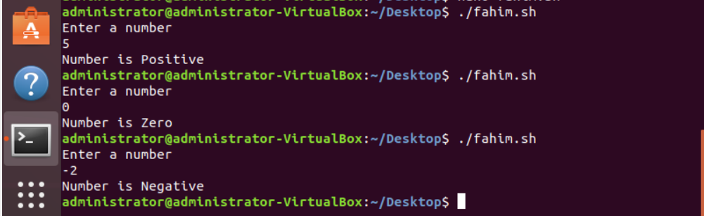

6.Word check
Commands:
word=snow
if [ $word == "now" ]
then
echo "true"
else
echo"false"
fi

Description:
This Bash script assigns the word snow to the variable word. The if condition checks whether the value of word is equal to "now". Since "snow" is not equal to "now", the condition evaluates to false. As a result, the else block is executed. The script prints "false" as the output.
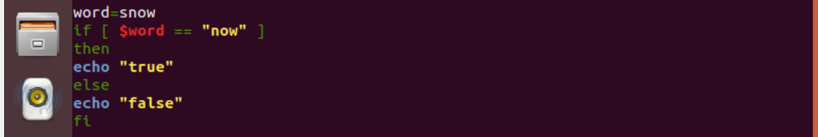

7.Word User Input Check
Commands:
echo "Enter something"
read word
if [ "$word" == "x" ]
then
echo "true"
elif [ "$word" == "y" ]
then
echo "true"
else
echo "false"
fi

Description:
This Bash script prompts the user to enter a value and stores it in the variable word. It first checks if the input is "x" using an if condition. If the input is "x", it prints "true". If the input is "y", the elif condition executes and prints "true". If the input is neither "x" nor "y", the else block prints "false".

View
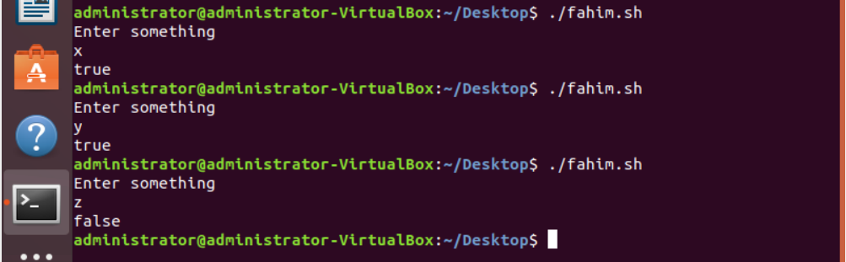

8.Division two number from user input
Commands:
echo "Enter two number"
read a b
if [ $b -eq 0 ]
then
echo "Error: Dividion by zero is not possible"
exit 1
fi
result=$(echo "scale=3; $a/$b" | bc)
echo "Division is: $result"

Description:
This Bash script asks the user to enter two numbers and stores them in variables a and b. It first checks if the second number b is zero to prevent division by zero. If b is zero, it prints an error message and exits the script. Otherwise, it calculates the division of a by b using bc with 3 decimal places. Finally, it prints the result of the division.
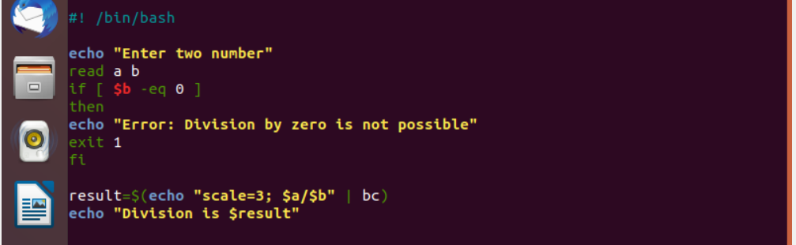
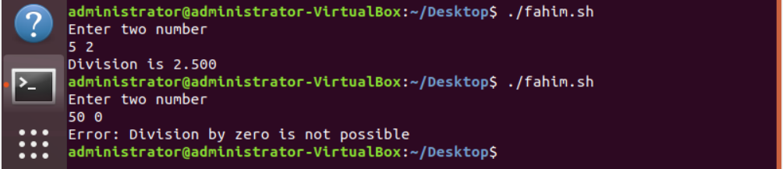

9.TASK

If a person’s age is between 18 and 70, they are eligible to vote; otherwise, they are not eligible to vote.

Vote Eligibility Check
#!/bin/bash

echo "Enter your age"
read age

if [ $age -ge 18 ] && [ $age -lt 70 ]
then
echo "ELIGIBLE FOR VOTE"
else
echo "NOT ELIGIBLE FOR VOTE"
fi

Description:
This Bash script prompts the user to enter their age and stores it in the variable age. It then checks whether the age is greater than or equal to 18 and less than 70 using a combined if condition. If the age satisfies both conditions, the script prints "ELIGIBLE FOR VOTE". If the age does not meet the criteria, it prints "NOT ELIGIBLE FOR VOTE". This ensures that only users within the eligible voting age range are identified correctly.



View

